DATA ACTIVITY 3 – COVID-19 IN INDIA JAN-MAR 2020

Task 3.1 – Create binary variable called has_deaths, indicating whether any deaths were reported:
Task 3.2 – Create frequency table using table() command to show death reporting patterns:
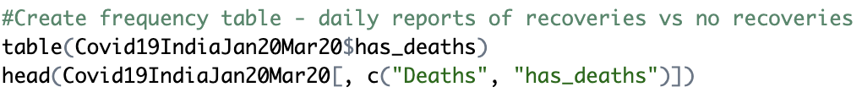

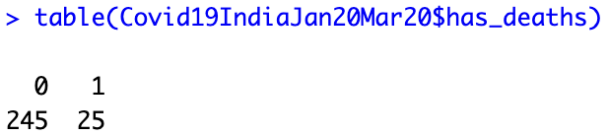

Task 3.3 – Convert to a factor variable with appropriate labels: ("No Deaths", "Deaths Reported"):
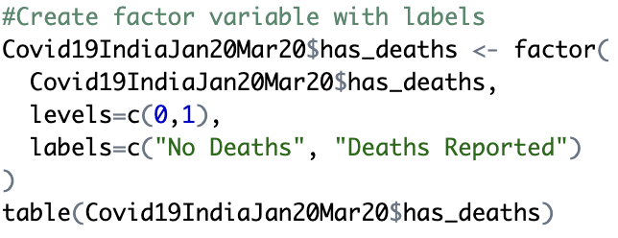

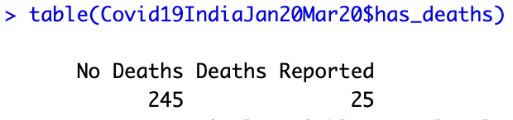

Task 3.4 – Create a categorical variable called case_level based on total confirmed cases (Indian + Foreign nationals)
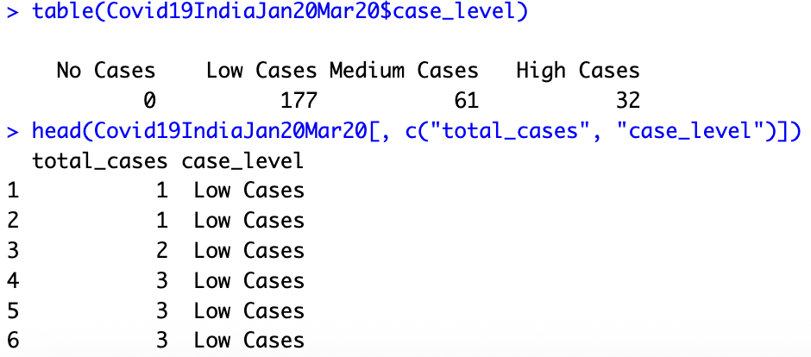
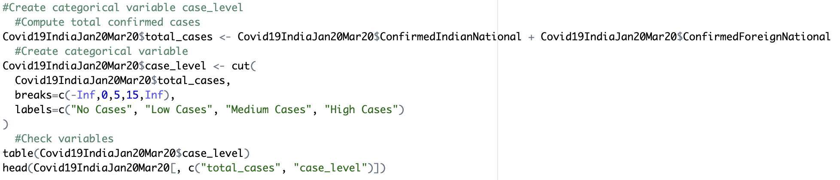
No cases = 0 cases; Low cases = 1-5; Medium cases = 6-15; High cases = 15+

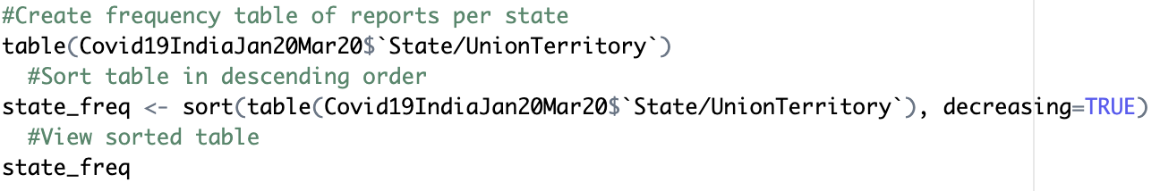
Task 3.5 – Create a frequency table for the State/Union Territory variable to see which states had the most frequent reporting:
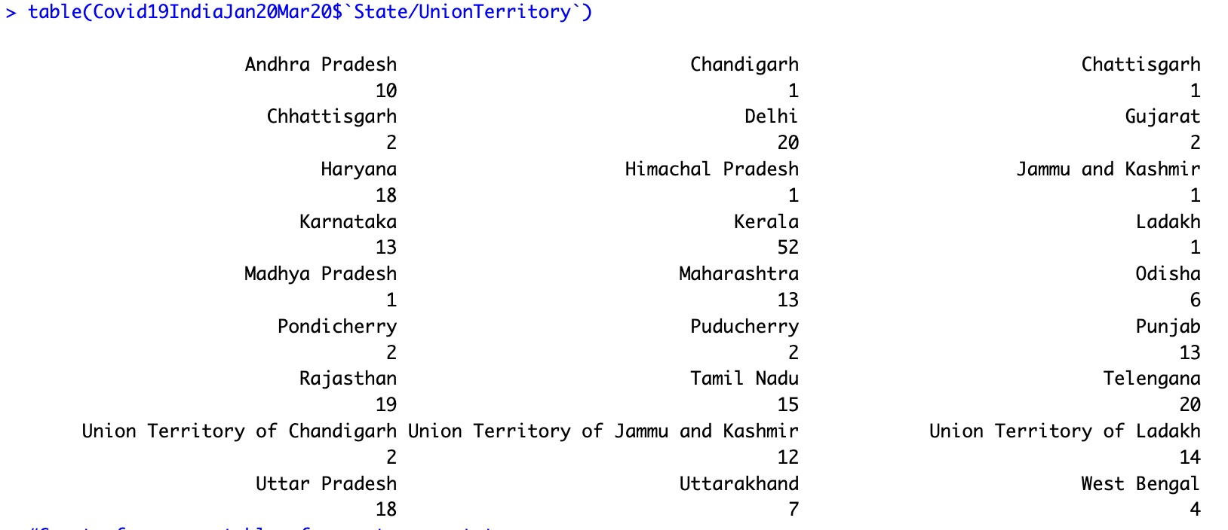

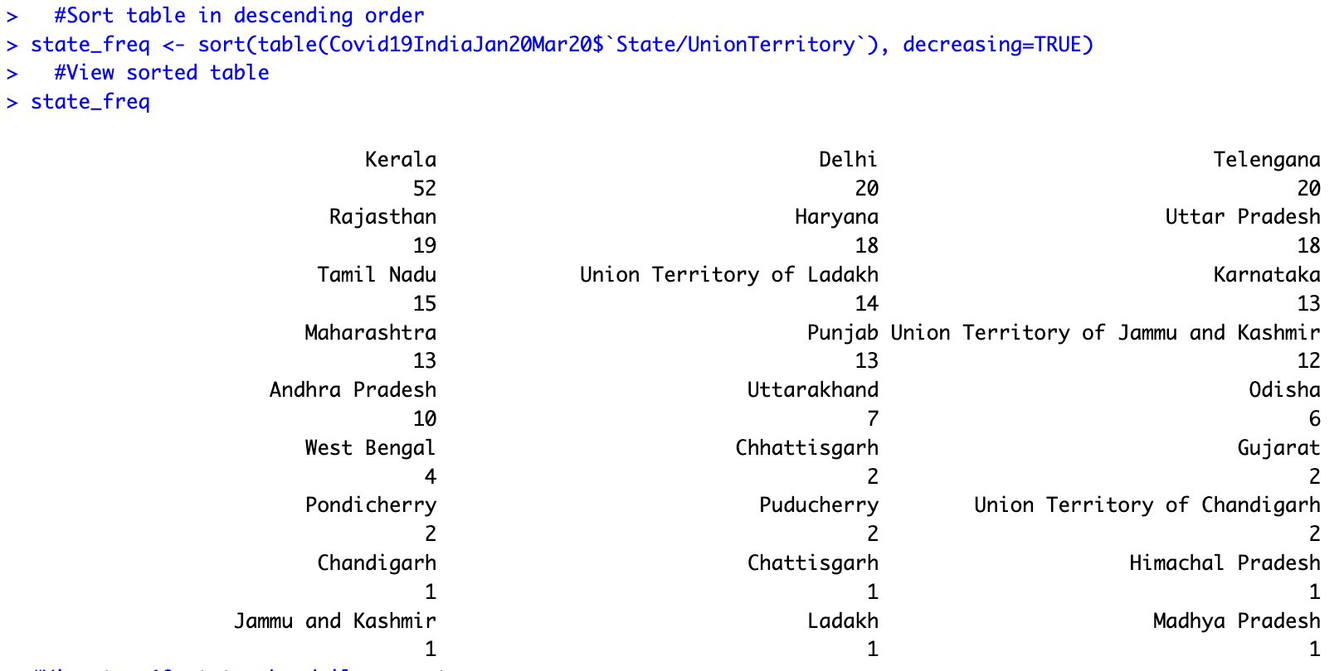

Task 3.6 – Identify the top 10 states with the highest no. daily reports:
